Insert & select di python
Buka terminal laiu install python3 dan psycopg2
$ sudo apt update
$ sudo apt install libpq-dev
$ sudo apt install python3-pip
$ pip3 install psycopg2
Jika sudah, buat file pythonya di directory manapun ( bebas )
Saya membuat file python bernama contoh2 di direktory /mnt/d
$ sudo mkdir /mnt/d/contoh2.py

Lalu buka filenya
$ sudo nano /mnt/d/contoh2.py

Jika sudah masuk kedalam filenya, coding querynya dengan seperti ini
import psycopg2

#Parameter koneksi ke database
db_params = {
'host': '172.20.204.156', # Ganti dengan host database Anda
'database': 'postgres', # Ganti dengan nama database Anda
'user': 'postgres', # Ganti dengan nama pengguna database Anda
'password': '478' # Ganti dengan kata sandi database Anda
}

try:
#Membuka koneksi ke database
connection = psycopg2.connect(**db_params)

# Membuat objek kursor
cursor = connection.cursor()

#Select Query
select_query = "select * from production.ossera"
#Query INSERT
query= """
Insert into production.testpy (date,hour,
reg_name,router_type,
router_name,interface_name,
availability,cpu_util,
cpu_util_max,buffer_used,
buffer_used_max,free_memory,
buffer_misses,buffer_misses_max,
latency,latency_max)
SELECT date,hour,
reg_name,router_type,
router_name,interface_name,
availability,cpu_util,
cpu_util_max,buffer_used,
buffer_used_max,free_memory,
buffer_misses,buffer_misses_max,
latency,latency_max FROM production.ossera
"""

cursor.execute(select_query, query)
connection.commit()

# Cetak hasil
print("Data berhasil dimasukkan ke database")
except (Exception, psycopg2.Error) as error:
print("Error saat terhubung ke database:", error)

finally:
# Tutup kursor dan koneksi
if connection:
cursor.close()
connection.close()
Lalu jalankan querynya :
$ python3 /mnt/d/contoh2.py

Membuat dataframe select
buat file python baru denga cara seperti diatas, tapi ganti sedikit nama filenya, disini saya menggunakan nama baru contoh
Buka file nya
$ sudo mkdir /mnt/d/contoh4.py

Lalu, coding query seperti ini
import psycopg2
from io import StringIO
import pandas as pd
#import numpy as np
#from psycopg2.extensions import register_adapter, AsIs

#Parameter koneksi ke database
def db_connect(db_access,jdbc='sql'):

server = db_access['address']
db = db_access['db']
username= db_access['username']
password= db_access['pass']
print('connecting',db)
if jdbc=='sql':
conn = pyodbc.connect('DRIVER={SQL Server};SERVER='+server+';DATABASE='+db+';UID='+username+';PWD='+ password)
curr = conn.cursor()

if jdbc=='postgres':
conn = psycopg2.connect(host=server, port='5432', dbname=db, user=username, password=password)
curr = conn.cursor()
return conn,curr

conn_log,curr_log = db_connect({
'address' : '172.20.204.156',
'username': 'postgres',
'pass' : '478',
'db' : 'postgres',
},'postgres')

# Register adapter untuk tipe data numpy.int64
#register_adapter(np.int64, AsIs)

# Data numpy.int64 yang akan dimasukkan ke dalam tabel
#data_numpy = np.int64(42)

#Select Query
select_query = "select * from production.ossera"

#, (data_numpy,))

df = pd.read_sql(select_query,conn_log)
#df = pd.io.sql.read_sql(select_query, engine, index_col = index)
# preprocessing
for column in df.columns:
df[column] = df[column].astype(str)
print (df)

Lalu jalankan codingannya
$ python3 /mnt/d/contoh4.py
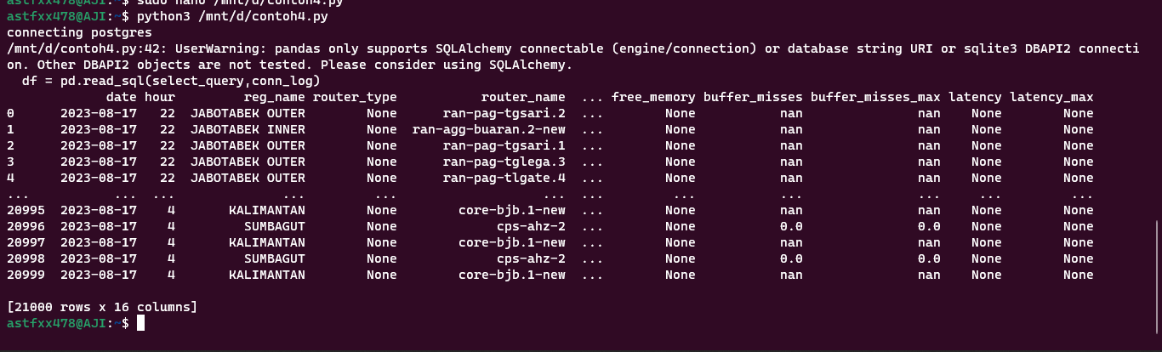
Selesai

